**Stage 1- Nightmare on Bay 1 💀**

**RULES:** USPSA Competition Rules, Latest Edition **COURSE DESIGNER:** Ryan Christenson / Jason Byerly

|  |  |
| --- | --- |
| **START POSITION: See written stage briefing.** | |
| **STAGE PROCEDURE**  See written stage briefing. | **SCORING**  **SCORING:** Comstock 32 rounds.  **TARGETS:** There are 16 cardboard targets.  **SCORED HITS:** 2 Best hits per carboard will be scored.  **START-STOP:**  Audible - Last shot  **PENALTIES:** Per USPSA Competition Rules |

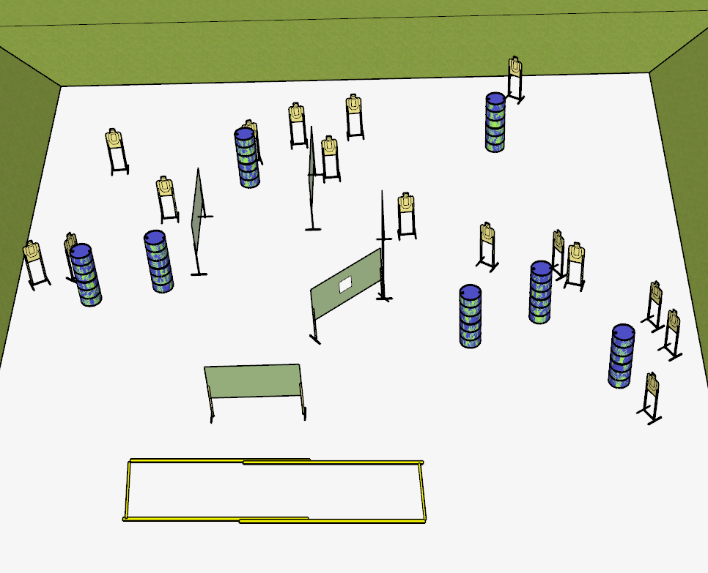

**Written Stage Briefing:**

**Stage 1 – Nightmare on Bay 1 💀 –** is a 32-round, 160 point, Comstock Long Course. There are 16 cardboard targets. The best 2 hits per cardboard target will be scored.

**Start position** Toes of both feet touching the rear fault line, facing downrange.

Handgun: Loaded and holstered with wrists below belt.

PCC: Loaded, stock on belt.

On the audible start signal, engage targets from within the shooting area.

**Setup Notes:**

**Use as many barrels as needed for force 5 shooting position.**

8 Single Wall Stands

1 Double Wall Stand

4 Solid Walls

1 Ported Wall

16 Target stands / 32 target sticks

14+ barrels